Vadym Ostanin

Common
OstaninvVadymvOleksiyovych
E-Mail: vadym.ostanin@gmail.com
Skype: vadim.ostanin
Telegram: https://t.me/vadymostanin
Citizenship: Ukrainian
Location: Kyiv

Specialty
- Expertise: development of applied applications in C++ for Window / Linux.
- The Education: Fiber optic communication lines.

Technology Profile | Programming Languages: C++, Java, Go, Processing, Python 3/Pandas/numpy.  OS: Ubuntu, Linux’s kernel, Windows  DB and tools: MySQL, SQLite, Wireshark, ssh, scp, sed, awk  Frameworks: Junit/PowerMockito/Mockito, STL, Libgdx, Chipmunk2D  IDE and tools: Eclipse, VS Code, IDEA, Android Strudio, Git,  Network and admin tools: Wireshark, tcpdump, ssh, scp  MCUs: STM32, Arduino, ESP32, ESP8266, ATTINY85  Protocols: (TCP/UDP)/IP, HTTP, SOAP, MQTT,  Bluetooth/WiFi (ESP32/ESP8266),  Interface: UART, I2C  Virtual cloud: Docker, AWS  ALogrithms: Qsort, Logistic Regresion, SVM, NeuralNetworks, CNN, Reverse kinematic  3D Printing: Tevo Tarantula / OpenSCAD  Misc: experience in temporary team lead, agile and scrum methodologies, full large-scale project life cycle.

16 years of experience in IT industry – telecommunication, networks. Wide area of expertise;
Strong understanding of the software development life cycle;
Experienced in development;
Experienced in client-server applications and embedded software for mobile devices;
Acted as a temporary team lead, overseeing the team's operations, task distribution, and project progress while ensuring timely delivery during the lead's vacation

Qualifications, a brief summary
Professional developer applied projects of high complexity. Experience: more than 5 years. Deep knowledge of the technological aspects of programming and operating systems. The long experience of large groups. Extensive experience in the development and support of large projects. Extensive experience in large companies (Comodo, Luxoft, Samsung SRK, Infopulse)

Education
The institution | From | Till | Speciality
Odessa Railway College Dzerzhinsky | 1999 | 2003 | "Maintenance and repair of the train"
Odessa Communication Academy named Popov | 2003 | 2008 | Fiber Optical Line Communications
“Step” – Computer academy | 2002 | 2004 | Developer

Job History
Name | Position | Range | The reason for changing jobs
Odessa Nation Academy named Popov A.S. | Engineer | 2004 - 2008 | Complete education
PSOFT/COMODO Ukraine | Middle Developer C++ | Aug 2008-Sep 2011 | More maintenance than adding features
Luxoft Ukraine | Engineer | Sep 2011-  Apr 2013 | Transfer to Kiev
Samsung SRK Kyiv | SeniorvEngineer, Developer C/C++ | Apr 2013 –  Jun 2015 | Only maintence on project
IntroPro | SeniorvEngineer, Developer C/C++ | Jul 2015-  Aug 2017 | Project finished
InfoPulse | Engineer C/C++ Developer | Aug 2017 – Nov 2019 | Only maintence on project
 | Senior Developer C++ | Nov 2019 – Present | Project finished

Professional Experience
Senior Developer C++  Nov 2019 – Sep 2024  Automotive embedded | Project details:  - Fullstack developing and support for 5G Qualcomm connected TCUs: architecture , requirements, userguides, development, unit-test, smock-test, integration tests  - Support and enhancing all components, most are client-server, like:  - Time with GPS manager, Multiplatform(Arm7, Arm8) Software updater,  component for communication with Qualcomm 5G CPU for SMS/calls, etc.,  - Patching CVEs for all opensource repositories, e.g., Linux-kernel, Systemd, etc..  - Full-stask dev:Archs, Reqs, UserGuides, Implementation, Google unit-testing, Smock-testing  - Qualcomm case support  Language/Technologies/Frameworks:  - C  - C++ 14/STL  - Qt5, QML, QtCreator  - Python  - Google C++ Testing Framework, GLib  - Qualcomm Telematics SDK, Dbus  - V2X, Eclipse Sumo simulator  Tools:  - Git/GitLab/Gerrit, Jira, Confluence, Rhapsody, Jazz Team for IBM DOORS Next, SmartBear Collaborator  - Buildroot, CMake, Ubuntu, VirtualBox, VMWare Horizon Client,  - Binary analysys tool Cutter, QFIL, QPST, QCAP,  Qualcomm Package Manager 3  Certification:  - AWS Certified Cloud Practitioner

InfoPulse, Kiev, Ukraine  Senior Developer C++  2017 – Nov 2019  Automotive Multimedia HeadUnit, Navigation system | Project details:  - Developing address search feature of navigation system for embedded automotive multimedia HeadUnit  - Enhancing WiFi system for automotive multimedia HeadUnit  - Developing/maintaining RESTFull protocol service for IPC  - Using Docker micro services for isolate integration test environment  - Acted as a temporary team lead  Language/Technologies/Frameworks:  - C++ 14/STL, Python 3  - Google unittests, Automation tests using Python 3  - Docker  - Git/GitLab, Jira  - Linux bash scripts, systemd  - NDS SQLite  Tools:  Ubuntu, CMake, Bob(https://github.com/BobBuildTool/bob), VirtualBox, QtCreator, Postman
IntroPro, Kiev, Ukraine  Senior Engineer  July 2015 - 2017  Department - DTVLA | Project details:  - Developing and maintenance of embedded TV Box UI using Java  - Decoding received raw satellite signal for TV  - Java Unit-test  - Developed and maintained Android applications using Kotlin and JNI for integrating native C/C++ code  - Utilized Android NDK for testing, debugging, and optimizing native libraries.  Technologies:  - Java, Kotlin  - Android SDK, Android JNI C/C++  - C/C++ 11  - Ant  - Junit/PowerMockito/Mockito  - Mercurial  - Jira  - Linux  - Docker  Tools:  Ubuntu, VirtualBox, Eclipse
Samsung, Kiev, Ukraine  Senior Engineer  April 2013 – July 2015  Department - Tizen Reference Application | Project details:  - Developing and enhancing features for Samsung Tizen Reference Application project( SMS/MMS, Calendar, Call, Email, Piano, etc. )  Key responsibility:  - Developing with code quality  - Developing Tizen Reference Application – applications that are integrated into the phone manufacturers other than Samsung.  - Code review in Git/Gerrit  - Acted as a temporary team lead  Technologies:  - C++ 14  - Chrominum based book creator  - Tizen 3.0 SDK  - control version system Git  - Make cross platform build for Tizen using GBS ( Git Build System ) tool  - Build app for Tizen 2.2, 2.3 Kiran  - Enlightenment Foundation Libraries and UI markup language – EDC  - Cross platform build using ubuntu-dev-tool and pbuilder  - Tizen IDE 2.2, 2.3  - Team Lead exchange  - Scram methodology  - Neural networks algorithms  - ML, Convolution NN, CNN, Audio DSP  - Genetic algorithms  - Blender 3D  - FreeCAD, OpensCAD  - Sounds recognition  - physics engine Chipmunk 2D  - OpenCV, FFMpeg
Luxoft, Odessa, Ukraine  Position: Engineer  September 2011 – April 2013 | Project details:  - Embedded Web browser, based on WebKit for Automotive system  Key responsibility:  - Developing with code quality  - Make integrated testing  - Make instruction for new employee linked to team.  Technologies:  - C++  - WebKit based browser developement  - Mocca framework  - Harman/Becker DSI IPC  - D-Bus IPC  - Perforce versioning system  - Bug tracking with Elvis  - QNX scripting  - io-hid library for mouse support in Automotive system
PSOFT/Comodo Ukraine  Position: Middle Developer C++  August 2008 – September 2011 | Project details:  - Endpoint Security Manager is administrative tool consist of the server(C#), admin console(Silverlight), endpoint side(C++)  Key responsibility:  - Developing and enhancing features for endpoint client  - Porting and maintenance Windows endpoint client to Ubuntu  - Porting and maintenance Ubuntu endpoint to Mac  - Maintenance Endpoint communication with other COMODO Product as COMODO Internet Security, Comodo Disk Encryptor  Technologies:  - C++  - IPC/COM  - IPC/Pipes  - STL  - ATL  - MFC  - Ubuntu  - Cocoa, Xcode, Objective-C  - Scrum
Professional Associations & Certifications

Professional Certifications | 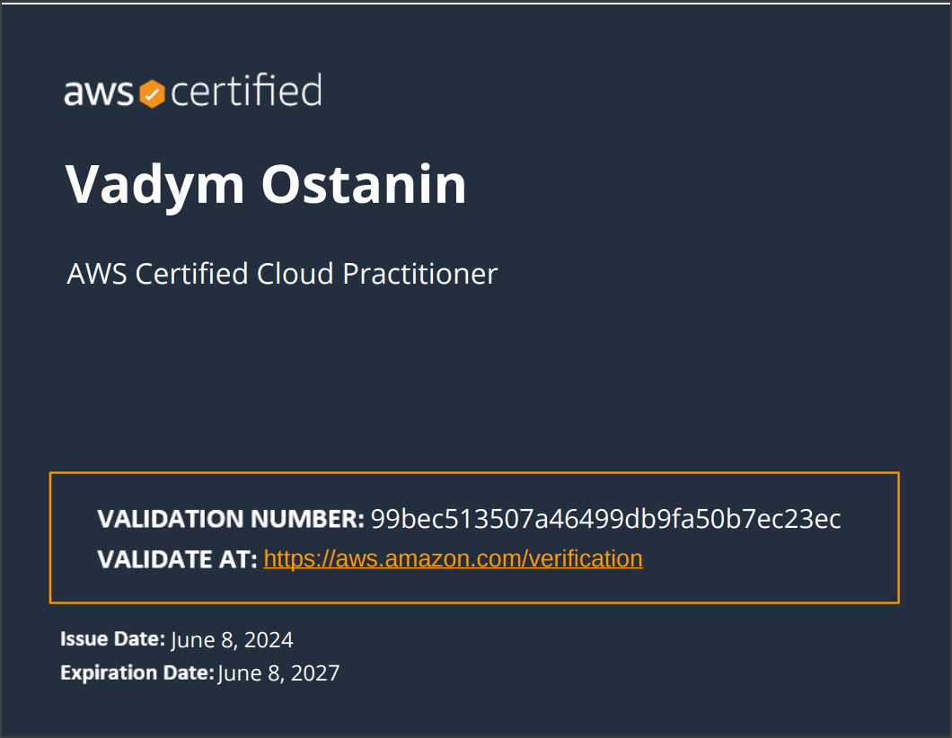
OpenSource | 3D view of quadratic equation with complex numbers  https://habr.com/ru/articles/329672/  https://github.com/vadimostanin/QuadraticEquationComplexNumber3D  WiFi power socket  https://habr.com/ru/articles/370093/  WiFi remote TV, Air condition controller  https://github.com/vadimostanin/ESP8266_TV_IR_MQTT_Control  Robot reverse kinematic engine  https://github.com/vadimostanin/Manipulator_reverse_kinematic  NN from scratch  https://github.com/vadimostanin/neural_networks  Creature constructor with physics simulation  https://github.com/vadimostanin/efl_painting_tool
Formal Education | Master degree in optical fiber for communication:  Odessa National Academy of Telecommunications  Odessa, Ukraine  2003-2008
Technology Profile | Programming Languages: C++, Java, Go, Processing, Python 3/Pandas/numpy.  DB and tools: MySQL, SQLite, Wireshark, ssh, scp, sed, awk  Frameworks: Junit/PowerMockito/Mockito, STL, Libgdx, Chipmunk2D  IDE and tools: Eclipse, IDEA, Android Strudio, Git, Docker  Network and admin tools: Wireshark, tcpdump, ssh, scp  MCUs: STM32, Arduino, ESP32, ESP8266, ATTINY85  Protocols: (TCP/UDP)/IP, HTTP, SOAP, MQTT,  Bluetooth/WiFi (ESP32/ESP8266),  Gyroscope (MCU-6050)  Interface: UART, I2C  Technologies: Docker, Git, Linux  Technics: Qsort, Logistic Regresion, SVM, NeuralNetworks, CNN, Reverse  3D Printing: Tevo Tarantula / OpenSCAD  Misc: experience in agile and scrum methodologies, full large-scale project life cycle.

